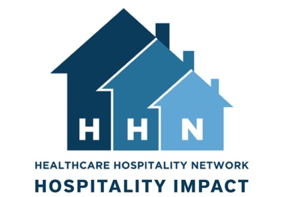
Healthcare Hospitality Impact Survey

Dear NAME OF GUEST,

As a previous guest of NAME OF HOUSE this past year, we welcome your thoughts regarding your experience with hospitality services. Your feedback is important not only to continue providing services to families but also this data will inform current and future services. Your participation involves completing the survey. The survey will take no more than 15 minutes to complete. Survey responses will help us improve our services to patients and caregivers who use hospitality services.

Internet Survey Instructions
If you prefer to complete the survey online, visit the following link: https://www.surveymonkey.com/r/HHN_2019, by October 3, 2019. Please note that responses will be confidential. Your individual survey responses will be housed in a Survey Monkey account linked to a single faculty member at Oklahoma State University. Individual responses will not be shared with hospitality house staff.

Paper Survey Instructions
If you prefer the enclosed paper copy and not the online version, once completed, please return it to us in the postage-paid self-addressed envelope enclosed by October 3, 2019. Please do not complete both versions. Completed surveys will be mailed to Philos Hospitality, Inc. in Tulsa, Oklahoma. No individual survey responses will be provided to participating hospitality houses. Only researchers from Oklahoma State University, working on survey response reports, will have access to individual survey data.

Whichever method you choose, we ask that you answer as honestly and openly as possible. It is important to note that ALL INFORMATION IS CONFIDENTIAL AND YOUR PRIVACY IS PROTECTED. To better keep your identity undisclosed, the survey will not ask for your name or contain information that will personally identify you. There should be minimal to no risk in taking this survey.

This project has been approved by the Institutional Review Board (IRB) at Oklahoma State University. Your participation is voluntary and there is no penalty if you do not wish to participate. You may stop the survey at any time or skip any questions you do not wish to answer. If you have any questions about completing the questionnaire, about being in this study, or about your rights as a research study participant, you may contact the lead researcher, Denna Wheeler, Ph.D. (denna.wheeler@okstate.edu or 918.584.4323) or the Oklahoma State University Research Compliance Office by mail at 223 Scott Hall, Stillwater, OK 74078, email at irb@okstate.edu or phone, 405.744.3377.

By completing this survey, you are indicating that you are at least 18 years old, have read this document, have had any questions answered, and voluntarily agree to take part in this research study. You may keep this form for your records or for internet surveys, you may print a copy of this consent agreement for your records.

Sincerely,

SIGNATURE OF HOUSE CONTACT
LOGO
HOUSE NAME

